Project Overview
This project performs end-to-end Exploratory Data Analysis (EDA) and Business Intelligence reporting on a multi-table retail dataset containing 830 orders, 2,155 order records, 91 customers, 77 products, and 29 suppliers across 21 countries.
The dataset was transformed into an analytics-ready format using data cleaning, feature engineering, and relational data modeling, followed by exploratory analysis and dashboard development in Excel and Power BI.
The goal of the project is to uncover patterns in customer behavior, product demand, revenue drivers, and supply chain performance. By leveraging pivot analysis, statistical methods, and interactive visualizations, the project converts raw transactional data into actionable business insights.

Project Objectives
The key objectives of this project were to:
- Perform exploratory data analysis (EDA) to understand sales, customer behavior, and product performance.
- Identify high-value customers and purchasing patterns through segmentation and order analysis.
- Evaluate product and category performance to determine key revenue drivers.
- Analyze order trends and seasonality to support demand forecasting.
- Assess supplier distribution and pricing patterns to identify supply chain dependencies.
- Monitor employee and shipping performance to understand operational efficiency.
- Build interactive dashboards and KPIs for business intelligence reporting.

Project Significance
This project demonstrates how data analytics and business intelligence techniques can support operational and strategic decision-making in retail and supply chain environments.

Key Business Insights
- Identified Beverages as the highest revenue-generating category, contributing over ₹267K in sales.
- Revealed that average orders per customer (~9 orders) indicate a strong repeat customer base.
- Found weak correlation between price, stock levels, and sales, suggesting that demand is driven more by product category and customer preferences.
- Highlighted top-performing products and customers, revealing revenue concentration patterns typical of the Pareto (80/20) principle.
- Detected seasonal order trends, enabling better demand planning and inventory management.
- Identified supplier dependency risks, where a small number of suppliers account for multiple products.

Business Impact
The insights from this analysis can help organizations:
- Improve customer retention and targeting strategies
- Optimize inventory and demand planning
- Strengthen supplier and procurement decisions
- Enhance operational efficiency and shipping performance
- Support data-driven decision-making through dashboards and KPIs

Tools & Technologies Used
- Excel: Pivot Tables, Power Query, Advanced Formulas
- Power BI: Data Modeling, DAX Measures, Interactive Dashboards
- Analytics Techniques:
  - Exploratory Data Analysis (EDA)
  - Customer Segmentation
  - Correlation Analysis
  - Anomaly Detection (Z-score)
  - Time-Series Trend Analysis

Data Dictionary
1 Suppliers table
Columns Data Type Description
SupplierID Number Unique identifier for suppliers table
CompanyName Text Name of the company
ContactName Text Name of the contact person
ContactTitle Text Position of the contact person
Address Text Address of the supplier
City Text City of the supplier
Region Text Region of the supplier
PostalCode Text Postal code of the supplier
Country Text Country of the supplier
Phone Text Phone of the supplier
Fax Text Fax of the supplier
Products Supplied Number Custom column -> Total number of products
supplied by the supplier

2 Shippers table
Columns Data Type Description
ShipperID Number Unique identifier for shippers table
CompanyName Text Name of the shipping company
Phone Text Phone of the shipper
Orders Shipped Number Custom Column -> Total number of products
shipped by the shipper
Total Freight Currency Custom Column -> Total freight charged by the shipper

3 Products table
Columns Data Type Description
ProductID Number Unique identifier for Products table
ProductName Text Name of the product
SupplierID Number Reference to the SupplierID in Suppliers Table
CategoryID Number Reference to the CategoryID in Categories Table
QuantityPerUnit Text Quantity in the single unit
UnitPrice Number Marked Price per unit
UnitsInStock Number Number of units in stock
UnitsOnOrder Number Number of units ordered in total
ReorderLevel Number Inventory quantity that triggers a new order to suppliers –
(Average Daily Usage × Lead Time) + Safety Stock
Discontinued Number 0/1 - Whether the product is discontinued or n
Total Orders Number Custom Column -> Total orders of the products placed
Total Quantity Sold Number Custom Column -> Total quantity of the products sold
Total Cost Currency Custom Column -> Total cost of the product
Total Sales Currency Custom Column -> Total sales of the product
Gross Profit per unit Currency Custom Column -> (Revenue - Sales) for each unit
Total Gross Profit Currency Custom Column -> Total gross profit for each product
Product Status Text Custom Column -> Whether the product is
ongoing or discontinued

4 Orders table
Columns Data Type Description
OrderID Number Unique identifier for Orders table
CustomerID Text Reference to the CustomerID in Customers Table
EmployeeID Number Reference to the EmployeeID in Employees Table
OrderDate Date Date of the order
RequiredDate Date Date till which the product is required
ShippedDate Date Date of the product shipping
ShipVia Number Reference to the ShipperID in Shippers Table
Freight Currency Freight charged for the product
ShipName Text Name of the ship
ShipAddress Text Address of shipment
ShipCity Text City of shipment
ShipRegion Text Region of shipment
ShipPostalCode Text Code of shipment
ShipCountry Text Country of shipment
Revenue Currency Custom Column -> Marked_price * Quantity * (1-discount)
Total Gross Profit Currency Custom Column ->
[[Marked_price * (1-discount)] - Cost_price] * quantity
Net Profit Currency Custom Column -> Total Gross profit – Freight_charges

5 Order Details table
Columns Data Type Description
OrderID Number Reference to the OrderID in Orders Table
ProductID Number Reference to the ProductID in Products Table
UnitPrice Currency Cost Price per Unit of the product
Quantity Number Quantity of the product ordered
Discount Number Discount on the product amount
Total Cost amount Currency Custom Column -> Total cost amount of the product
Order Date Date Custom Column -> Order date from orders table
UnitPrice (Marked) Currency Custom Column -> Marked price from products table
Total revenue Currency Custom Column -> Marked_price * Quantity * (1-discount)
Gross Profit Currency Custom Column ->
[[Marked_price * (1-discount)] - Cost_price] * quantity
Category Text Custom Column -> Category from categories table
Category Name Text Custom Column -> Category name from categories table

6 Employees table
Columns Data Type Description
EmployeeID Number Unique identifier for Employees table
FirstName Text First Name of the employee
LastName Text Last Name of the employee
Title Text Position in the organisation
TitleOfCourtesy Text Title Of Courtesy of the employee
BirthDate Date Birth Date of the employee
HireDate Date Hire Date of the employee
Address Text Address of the employee
City Text City of the employee
Region Text Region of the employee
PostalCode Text Postal Code of the employee
Country Text Country of the employee
HomePhone Text Home Phone of the employee
Extension Number Position in the organisation
Photo General Photo of the employee
Notes Text Brief information about the employee
ReportsTo Number EmployeeID to which current employee reports to.
-1 indicates the employee reports to no one
Total Orders Number Custom Column -> Total orders brought by the employee
Total sales Currency Custom Column -> Total sales made by the employee
Average sale per order Currency Custom Column -> Average sale per order made by the
employee

7 Customers table
Columns Data Type Description
CustomerID Number Unique identifier for Customers table
CompanyName Text Name of the customer company
ContactName Text Name of the contact person in the company
ContactTitle Text Position of the contact person in the company
Address Text Address of the customer
City Text City of the Customer
Region Text Region of the customer
PostalCode Text Postal Code of the customer
Country Text Country of the customer
Phone Text Phone of the customer
Fax Text Fax of the customer
Total Orders Number Custom Column -> Total orders placed by the customer
Average Order Amount Currency Custom Column -> Average order amount of the orders
placed by the customer
Total Amount Spent Currency Custom Column -> Total amount spent by the customer

8 Categories table
Columns Data Type Description
CategoryID Number Unique identifier for Categories table
CategoryName Text Name of the category
Description Text Description of the category
Picture General Picture of the category
Total Products Number Custom Column -> Total number of products in the category
Total cost Currency Custom Column -> Total cost of products in each category

ER Diagram
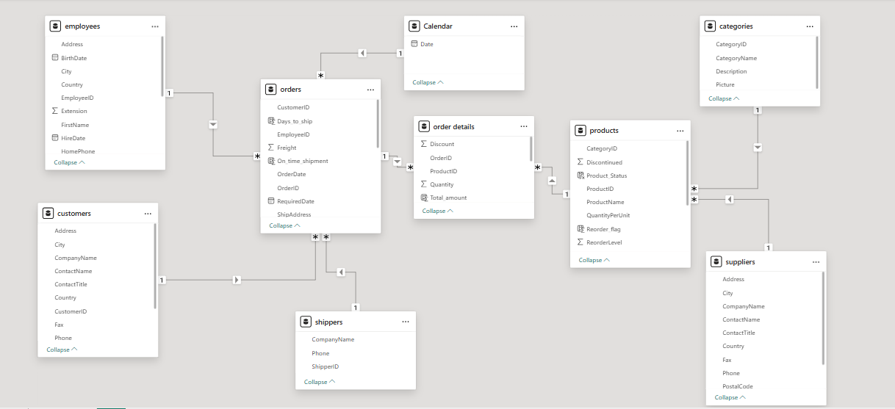

Steps to connect to Data
To Connect to data in Excel workbook:
- Go to Data Tab
- Click on Get Data option
- Select From File Option
- Select From Text/CSV
- Select .csv data file you want to load
- Click on Transform data
- Clean and preprocess the data
- Click on Save and Close option

To Connect to data in Power BI desktop:
- Go to Home Tab
- Click on Get Data
- Click on Text/CSV
- Select the data file you want to load
- Click on Transform
- Clean the dataset
- Click on Close and Apply

Problem Statements with Solutions and Insights

Excel EDA Solutions
- What is the average number of orders per customer? Are there high-value repeat customers?
Average order per customer = 9.12
Top 10 customers with most number of orders:
Customers | Number of Orders | Amount Spent
QUICK | 28 | $1,14,693.87
ERNSH | 30 | $1,11,362.43
SAVEA | 31 | $1,08,703.29
RATTC | 18 | $57,317.50
HUNGO | 19 | $52,623.64
HANAR | 14 | $33,591.61
MEREP | 13 | $32,827.90
KOENE | 14 | $32,040.65
FOLKO | 19 | $30,345.03
FRANK | 15 | $29,477.64
Grand Total | 201 | $6,02,983.56

- How do customer order patterns vary by city or country?
Customer order patterns by country:

We can see that most number of orders and most revenue is generated from Germany and USA.

Customer order patterns by cities:

- Can we cluster customers based on total spend, order count, and preferred categories?

We can cluster customers based on their Spending amount and order count:
High spend and high order count: VIP
High spend and low order count: High ticket clients
Low spend and high order count: Frequent buyers
Low spend and low order count: Casual buyers

- Which product categories or products contribute most to order revenue?
Product categories sorted by contribution in order revenue:
 | CategoryID | Total Revenue
 | 1 | $ 43,44,209.00
 | 2 | $ 14,66,221.50
 | 3 | $ 25,85,894.48
 | 4 | $ 26,28,507.70
 | 5 | $ 6,46,663.50
 | 6 | $ 13,60,643.96
 | 7 | $ 4,83,931.50
 | 8 | $ 19,06,347.39
 | Grand Total | $ 11,40,62,809.07

Top 10 Products by order revenue sorted by contribution in order revenue:

Product Name | Total Revenue
Côte de Blaye | $ 1,64,160.50
Thüringer Rostbratwurst | $ 92,347.34
Raclette Courdavault | $ 82,280.00
Camembert Pierrot | $ 53,618.00
Tarte au sucre | $ 53,391.90
Gnocchi di nonna Alice | $ 47,994.00
Manjimup Dried Apples | $ 46,958.00
Alice Mutton | $ 38,142.00
Carnarvon Tigers | $ 33,687.50
Rössle Sauerkraut | $ 29,184.00
Grand Total | $ 75,07,836.39

- Are there any correlations between orders and customer location or product category?
Order count and Total revenue by countries:
Countries | Total Revenue | Total orders
Argentina | $8,310.88 | 16
Austria | $1,37,273.51 | 40
Belgium | $36,939.43 | 19
Brazil | $1,14,637.36 | 83
Canada | $55,813.10 | 30
Denmark | $36,828.97 | 18
Finland | $20,627.19 | 22
France | $89,242.32 | 77
Germany | $2,42,495.09 | 122
Ireland | $52,623.64 | 19
Italy | $16,666.64 | 28
Mexico | $25,070.34 | 28
Norway | $6,000.35 | 6
Poland | $3,646.70 | 7
Portugal | $12,872.63 | 13
Spain | $18,815.49 | 23
Sweden | $56,660.20 | 37
Switzerland | $33,260.86 | 18
UK | $63,109.44 | 56
USA | $2,61,513.44 | 122
Venezuela | $61,295.39 | 46
Grand Total | $13,53,702.97 | 830

Order count and Total revenue by Product Categories:
Product Categories | Total revenue
Beverages | $2,88,694.65
Condiments | $1,13,992.56
Confections | $1,79,863.65
Dairy Products | $2,51,147.60
Grains/Cereals | $1,01,646.94
Meat/Poultry | $1,74,622.55
Produce | $1,05,745.71
Seafood | $1,37,989.31
Grand Total | $13,53,702.97

- How frequently do different customer segments place orders?
Order frequency for France, Germany, Austria, Brazil, UDA, UK, and Venezuela was more compared to others, especially in year 1995 and year 1996.

- What is the geographic and title-wise distribution of employees?
Count of Employees | Country
Employee Title | UK | USA | Grand Total
Inside Sales Coordinator |  | 1 | 1
Sales Manager | 1 |  | 1
Sales Representative | 3 | 3 | 6
Vice President, Sales |  | 1 | 1
Grand Total | 4 | 5 | 9

- What trends can we observe in hire dates across employee titles?
Year and Title | Count of Title
1992 | 3
Sales Representative | 2
Vice President, Sales | 1
1993 | 3
Sales Manager | 1
Sales Representative | 2
1994 | 3
Inside Sales Coordinator | 1
Sales Representative | 2
Grand Total | 9

Every year 2 sales representatives have been hired, with a total of 3 employees hired each year.

- What patterns exist in employee title and courtesy title distributions?
Employee Title and Courtesy Title | Total Employees
Inside Sales Coordinator | 1
Ms. | 1
Sales Manager | 1
Mr. | 1
Sales Representative | 6
Mr. | 2
Mrs. | 1
Ms. | 3
Vice President, Sales | 1
Dr. | 1
Grand Total | 9

- Are there correlations between product pricing, stock levels, and sales performance?
Field 1 | Field 2 | Correlation | Explaination
Product Price | Stock level | -0.2 | Approx. no correlation between the product price and stock
Product Price | Sales Performance | 0.87 | Higher the product price, higher the revenue per sale, and higher the sales performance
Stock level | Sales Performance | -0.2 | Approx. no correlation between the stock and sales performance

- How does product demand change over months or seasons?
Row Labels | Count of OrderID
1994 | 324
Qtr3 | 128
Aug | 59
Sep | 69
Qtr4 | 196
Oct | 57
Nov | 70
Dec | 69
1995 | 1026
Qtr1 | 245
Jan | 81
Feb | 74
Mar | 90
Qtr2 | 254
Apr | 72
May | 86
Jun | 96
Qtr3 | 237
Jul | 76
Aug | 77
Sep | 84
Qtr4 | 290
Oct | 95
Nov | 103
Dec | 92
1996 | 805
Qtr1 | 388
Jan | 114
Feb | 145
Mar | 129
Qtr2 | 417
Apr | 178
May | 190
Jun | 49
Grand Total | 2155

In 1994 and 1995, in Quarter 4, the sales were maximum. And in 1996, sales were more as compared with previous years.

- Can we identify anomalies in product sales or revenue performance?

We can see that in June 1996, there is a sudden drop in the number of orders. This is due to incomplete data of that month.
- Are there any regional trends in supplier distribution and pricing?
Country | Average Unit Price | Total Suppliers
Australia | $25.58 | 8
Brazil | $3.60 | 1
Canada | $23.29 | 4
Denmark | $8.92 | 2
Finland | $14.31 | 3
France | $53.36 | 5
Germany | $28.89 | 9
Italy | $21.06 | 5
Japan | $16.69 | 6
Netherlands | $8.18 | 2
Norway | $15.99 | 3
Singapore | $19.78 | 3
Spain | $15.35 | 2
Sweden | $11.90 | 5
UK | $14.56 | 7
USA | $13.57 | 12
Grand Total | $21.70 | 77

- How are suppliers distributed across different product categories?
Categories | Total Suppliers
Beverages | 8
Condiments | 8
Confections | 6
Dairy Products | 4
Grains/Cereals | 5
Meat/Poultry | 5
Produce | 5
Seafood | 8
Grand Total | 29

Suppliers are mostly concentrated in categories: Beverages, Condiments, and Seafood.

- How do supplier pricing and categories relate across different regions?
Average UnitPrice | Categories
Countries | Beverages | Condiments | Confections | Dairy Products | Grains/Cereals | Meat/Poultry | Produce | Seafood
Argentina | 43.17 | 15.60 | 26.05 | 19.53 | 15.60 |  | 29.15 | 9.28
Austria | 29.29 | 17.63 | 20.66 | 20.76 | 19.13 | 41.03 | 24.89 | 17.51
Belgium | 18.73 | 15.00 | 22.59 | 24.02 | 18.03 | 18.88 | 29.30 | 14.48
Brazil | 32.65 | 15.11 | 15.64 | 19.91 | 14.41 | 35.14 | 33.97 | 16.83
Canada | 29.73 | 15.16 | 19.44 | 22.90 | 18.66 | 28.20 | 23.20 | 19.91
Denmark | 38.06 | 15.05 | 18.16 | 27.00 | 5.60 | 32.50 | 32.67 | 15.53
Finland | 18.18 | 19.72 | 10.63 | 24.93 | 19.20 | 33.78 | 20.04 | 9.62
France | 24.45 | 15.75 | 20.18 | 20.21 | 15.38 | 34.98 | 28.44 | 20.42
Germany | 23.38 | 15.54 | 20.24 | 23.15 | 16.04 | 35.07 | 28.59 | 14.91
Ireland | 15.11 | 16.45 | 21.23 | 23.46 | 16.67 | 71.17 | 34.47 | 20.66
Italy | 8.54 | 13.87 | 16.19 | 24.02 | 12.24 | 21.10 | 25.04 | 15.90
Mexico | 23.63 | 17.18 | 11.67 | 17.93 | 10.20 | 35.84 | 30.48 | 18.56
Norway | 53.84 | 10.40 | 10.60 | 30.60 |  | 26.20 | 27.80 | 26.13
Poland | 11.50 | 22.80 | 23.70 | 17.60 |  | 5.90 | 25.20 | 10.60
Portugal | 16.33 | 14.45 | 9.62 | 32.80 | 25.25 | 52.45 | 42.40 | 24.80
Spain | 10.13 | 13.37 | 11.38 | 27.20 | 18.22 | 40.23 | 42.40 | 18.65
Sweden | 20.06 | 19.40 | 19.13 | 22.92 | 13.25 | 33.07 | 33.97 | 12.97
Switzerland | 11.73 | 26.67 | 22.99 | 24.73 | 21.26 | 48.13 | 25.20 | 12.56
UK | 13.74 | 15.58 | 21.48 | 20.30 | 13.62 | 36.74 | 31.92 | 10.83
USA | 35.01 | 16.58 | 21.62 | 20.96 | 23.10 | 37.51 | 28.01 | 15.93
Venezuela | 10.64 | 10.23 | 14.17 | 25.40 | 14.42 | 31.45 | 28.65 | 14.30

Power BI Analytical solutions
- How does customer distribution vary across different countries or cities? Use bar chart or map to visualize.
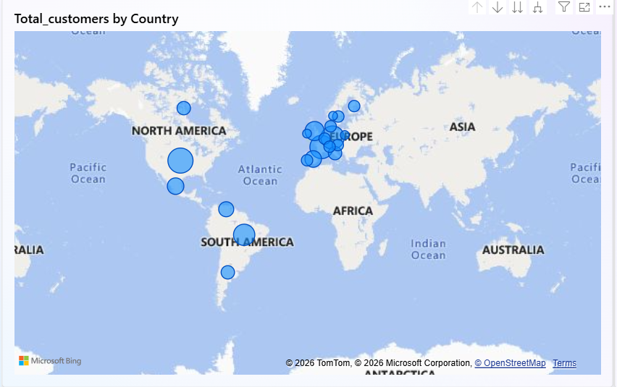
Top 5 countries by number of customers being: USA (13), France (11), Germany (11), Brazil (9), UK (7)

- What is the trend in customer orders over time? Use line chart or area chart to visualize.
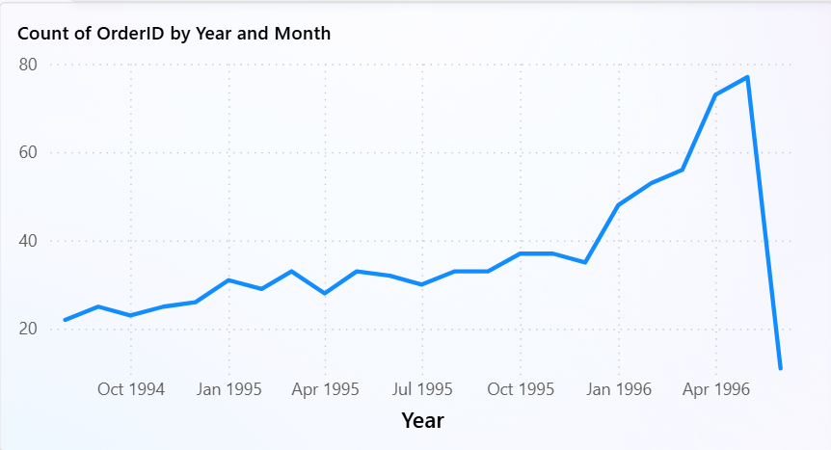
The number of orders is increasing from August 1994 (22 orders) to May 1996 (77 orders). Due to unavailability of data, we can see a sudden drop of orders in June 1996.
- What is the distribution of customers by Contact Title or Region? Use stacked bar chart or pie chart to visualize.
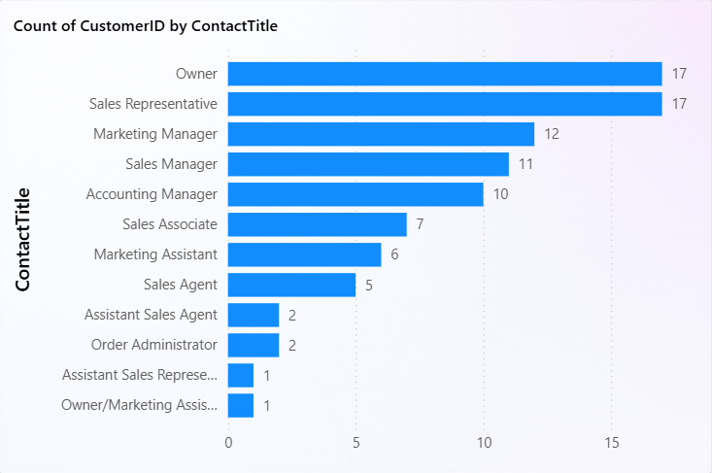
Majority of the customers are business owners and sales representatives of the businesses, followed by Marketing managers, sales managers, and Accounting managers.

- How does order volume change over time? Use line chart or stacked bar chart to visualize.
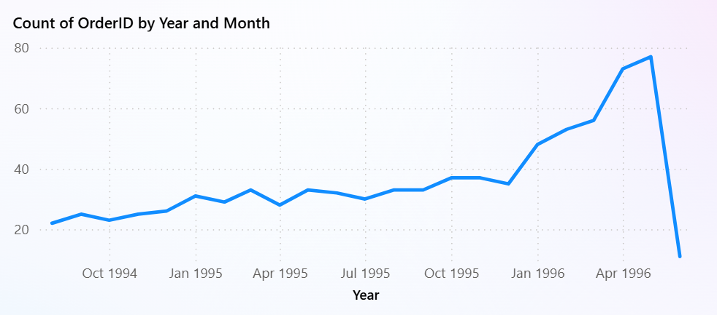
The number of orders is increasing from August 1994 (22 orders) to May 1996 (77 orders). Due to unavailability of data, we can see a sudden drop of orders in June 1996.

- What is the distribution of order values? Use histogram or box plot to visualize.
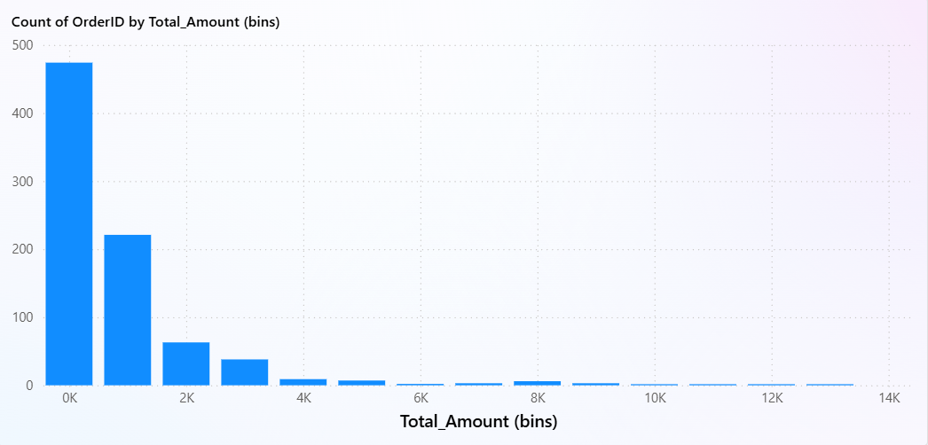
Majority of the orders have the order value in the range $0 - $2000

- What is the average order shipping duration? Use bar chart or box plot to visualize.
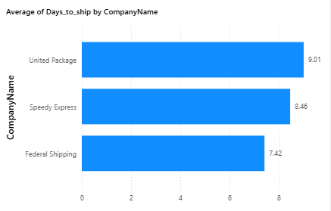
As shown, United Package on average takes most amount of time (9.01 days) to ship the order to customers, while Federal Shipping takes the least amount of time to ship the order (7.42 days).

- What is the count of employees by job title or region? Use stacked bar chart or tree map to visualize.
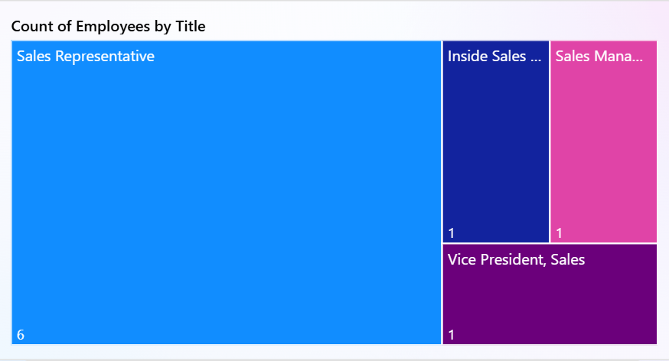

- What is the distribution of employee tenure? Use histogram or box plot to visualize.
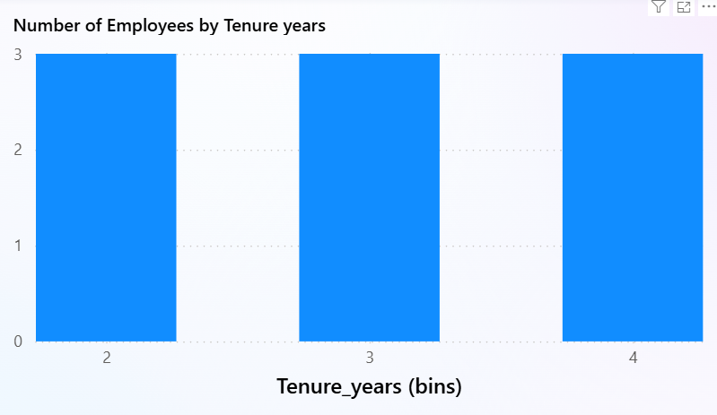
There are 3 employees with 2-year tenure, 3 employees with 3-year tenure, and 3 employees with 4-year tenure.

- What is the reporting structure among employees? Use org chart or hierarchical tree to visualize.
Since org chart or hierarchical tree map isn’t available in Power BI desktop, this visualization wasn’t created.

- Which products have the highest sales volume? Use bar chart or tree map to visualize.
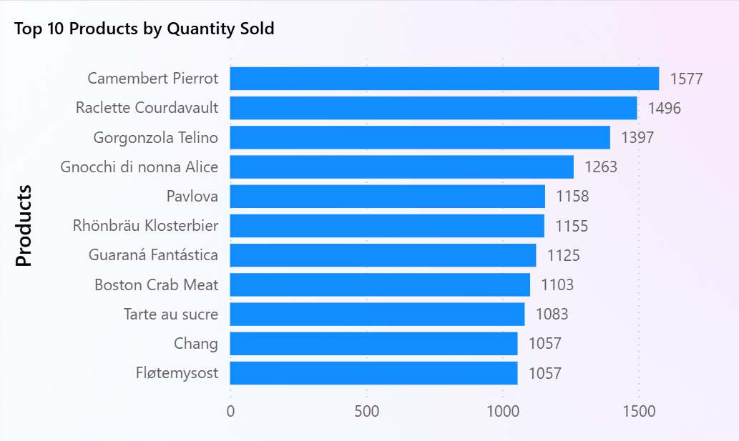

- How does the sales volume vary across different product categories? Use stacked bar chart or tree map to visualize.
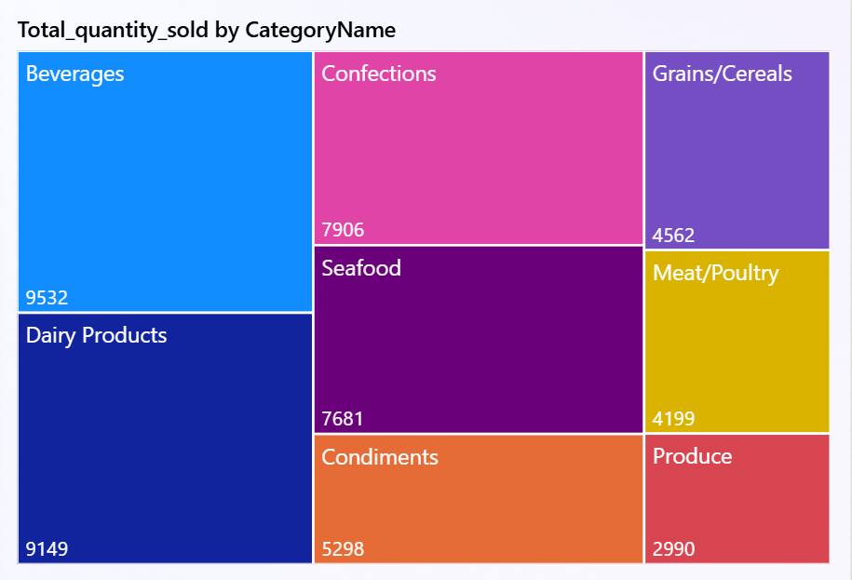

- Can we visualize the pricing distribution of products? Use box plot or histogram to visualize.
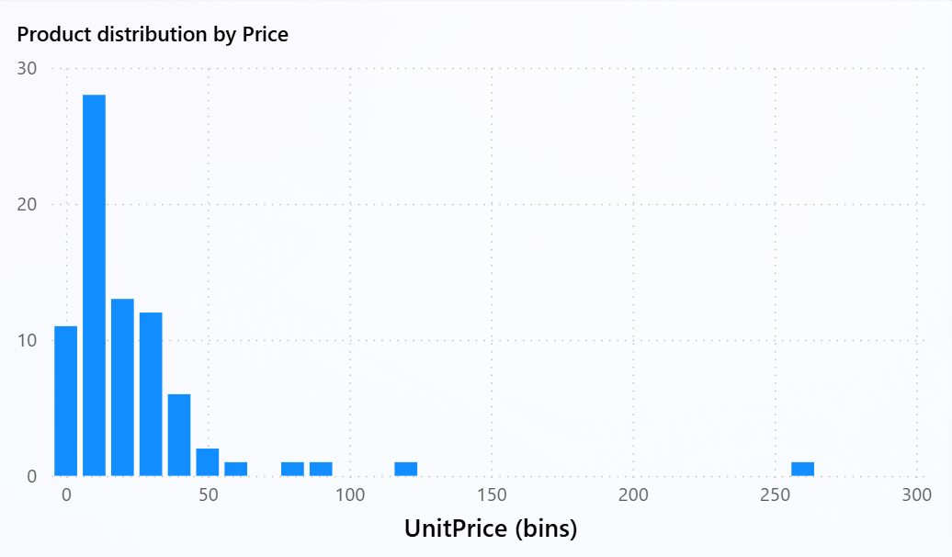
Most of the products have pricing in the range $5 - $45.

- How many products are supplied by each supplier? Use bar chart or pie chart to visualize.
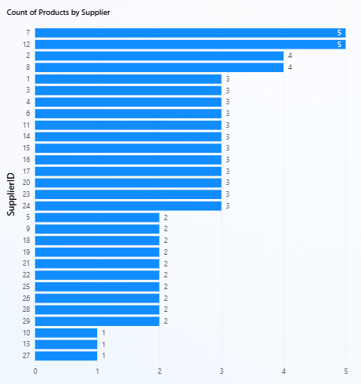
- How does product pricing vary across different suppliers? Use box plot or stacked column chart to visualize.
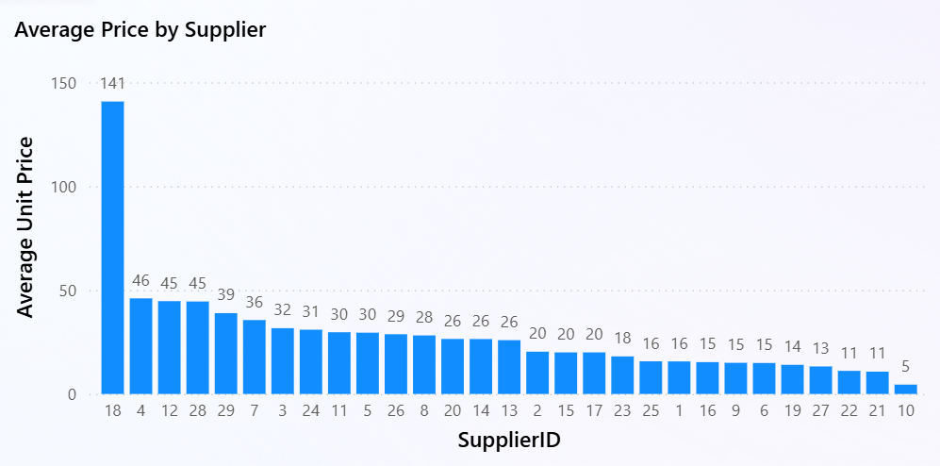

- What is the geographical distribution of suppliers? Use map chart or bubble map to visualize.
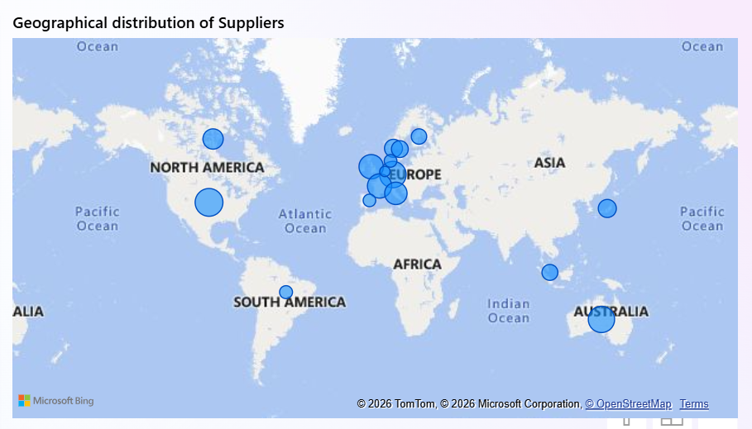

Conclusion
This project demonstrated how data analytics and business intelligence techniques can transform raw transactional data into meaningful insights that support strategic decision-making. By integrating multiple datasets related to customers, orders, products, suppliers, employees, and shipping operations, the analysis provided a comprehensive view of business performance across different operational segments.

Through exploratory data analysis, pivot analysis, statistical evaluation, and interactive visualization using Excel and Power BI, key patterns in customer behavior, product demand, sales performance, and supply chain operations were identified. The analysis revealed that revenue is largely driven by a few high-performing product categories and repeat customers, while demand patterns exhibit seasonal trends. Additionally, the study highlighted the importance of monitoring supplier dependencies, shipping efficiency, and employee performance to maintain operational effectiveness.

Overall, the project demonstrates the value of data-driven decision-making in improving customer retention strategies, optimizing inventory planning, and enhancing supply chain management. The insights generated through this analysis can help organizations make informed business decisions, improve operational efficiency, and identify opportunities for growth.

